Assignment 2 — Advanced Generative AI
Mini Project 1: Data Science with Generative AI
Mini Project 2: Software Development Using Generative AI

Prepared by: Divyanshu Sharma

Both mini projects are combined in this single document, in phase/part order, with the original prompts, AI outputs and code screenshots kept exactly as submitted. Sections marked “ADDED CONTENT” are new material written to cover items the assignment brief asked for that were missing from the original work.

Mini Project 1 — Data Science with Generative AI

Heart Disease Prediction Pipeline
Divyanshu Sharma

Part 1 — Dataset Selection
ADDED CONTENT — Divyanshu Sharma
Dataset Name: Heart Disease UCI (Cleveland database)
Source: UCI Machine Learning Repository — archive.ics.uci.edu/ml/machine-learning-databases/heart-disease
Rows: 303 Columns: 14
Target Variable: num (presence of heart disease, later collapsed into a binary target column)
I picked this dataset because heart disease is one of the most common causes of death, and a dataset that pairs patient vitals with a confirmed diagnosis is a natural fit for a classification pipeline. It is also a manageable size — 303 rows and 14 columns is large enough to train a model on but small enough to inspect by hand at every stage — and it mixes numerical fields (age, cholesterol, resting blood pressure) with categorical ones (chest pain type, thalassemia), which exercises every part of the ETL and EDA process rather than just one.
Below: original prompts, AI outputs and code exactly as generated in Google Colab.
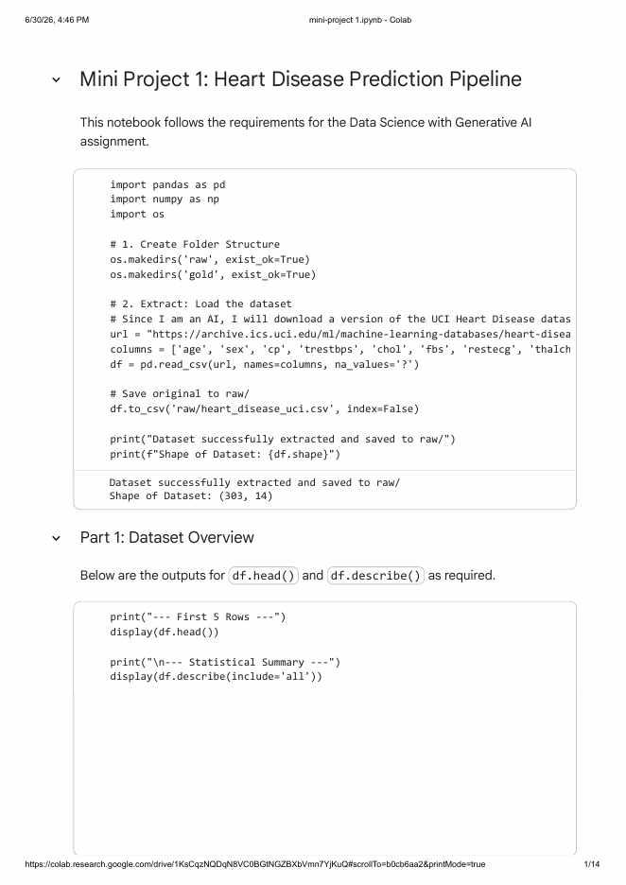

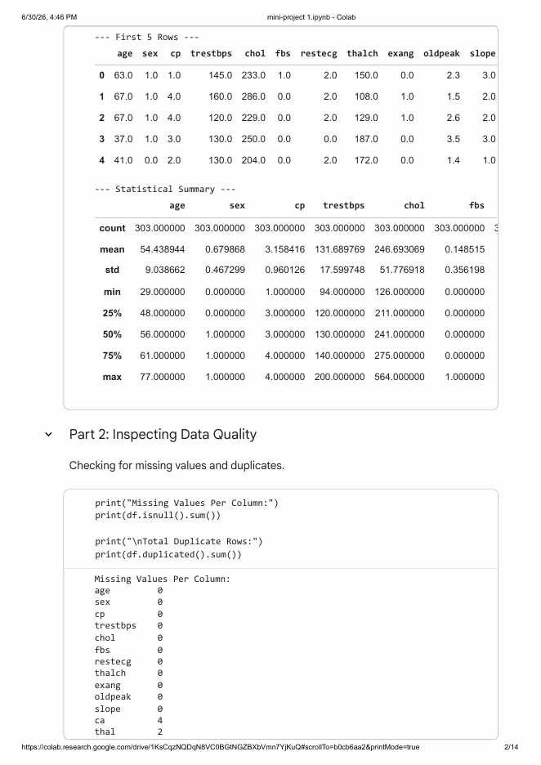

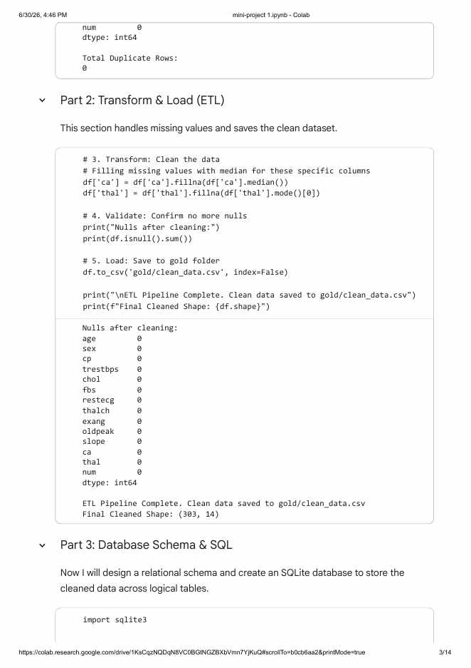

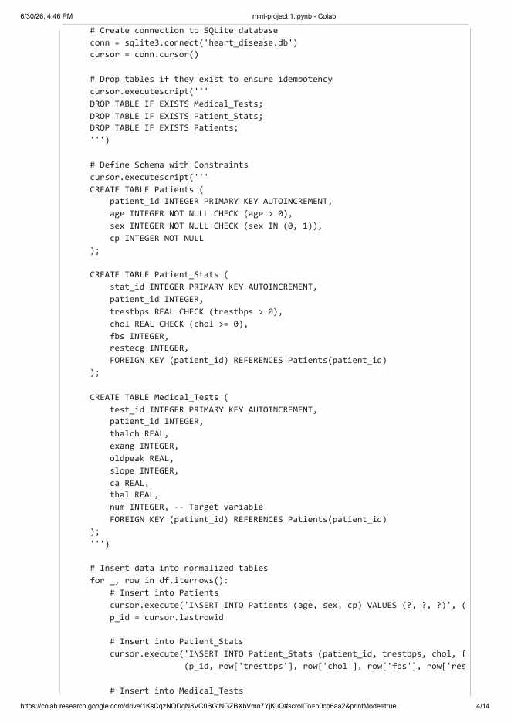

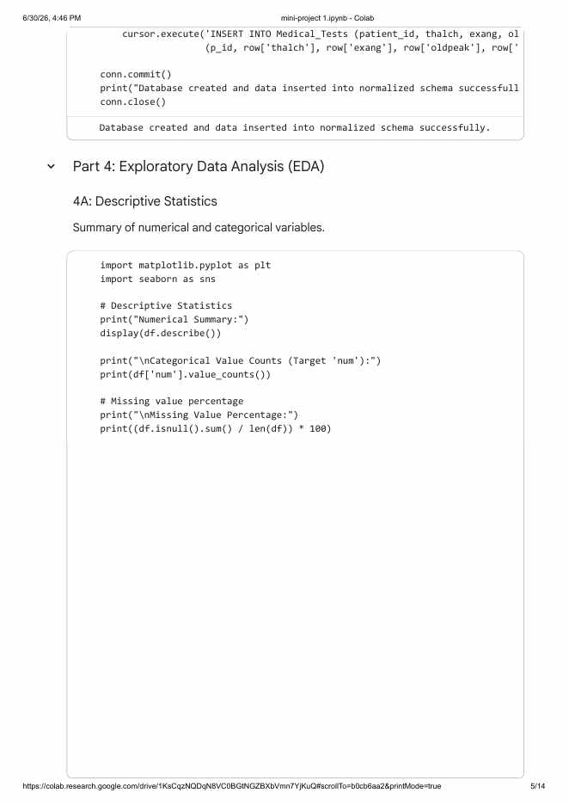

Entity Relationship Diagram — Description
ADDED CONTENT — Divyanshu Sharma
The schema is split into three tables that all share a common patient_id key, so no patient detail is stored twice.
Patients holds one row per patient — age, sex and chest pain type (cp), the fields that identify who the patient is.
Patient_Stats holds the vitals recorded at the visit — resting blood pressure, cholesterol, fasting blood sugar and resting ECG — and links back to Patients through patient_id.
Medical_Tests holds the results of the exercise test — max heart rate, exercise-induced angina, ST depression, slope, number of vessels coloured by fluoroscopy, thalassemia — along with the target column num, and also links back to Patients through patient_id.
Each Patients row connects to exactly one Patient_Stats row and one Medical_Tests row (a 1:1 relationship in both directions), so on a diagram the relationship lines would run Patients → Patient_Stats and Patients → Medical_Tests, both joined on patient_id.
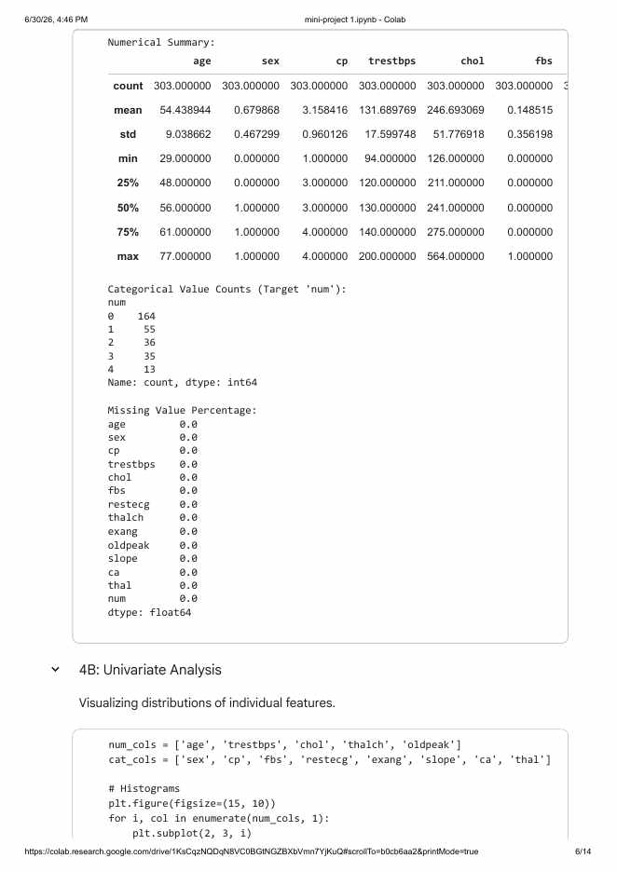

Interpretation of Descriptive Statistics
ADDED CONTENT — Divyanshu Sharma
The average patient here is about 54 years old, with ages ranging from 29 to 77, so the sample leans toward middle-aged and older adults rather than young patients. Close to 68% of the patients are male, which matches the well-known pattern that cardiac datasets from this era are male-heavy. Resting blood pressure averages around 132 mmHg and cholesterol averages around 247 mg/dl, both sitting just above what is usually considered a healthy range, which suggests this is a clinically referred population rather than a random sample of healthy people. Cholesterol also has a fairly wide spread (std. dev. of about 52) and a maximum of 564, far from the mean of 247, an early sign of the outliers that show up in the boxplots later on. Out of the five target classes (num = 0 to 4), more than half the patients fall in class 0 (no disease), so the dataset is moderately imbalanced, and that imbalance carries through to the binary target used for modelling in Part 5.
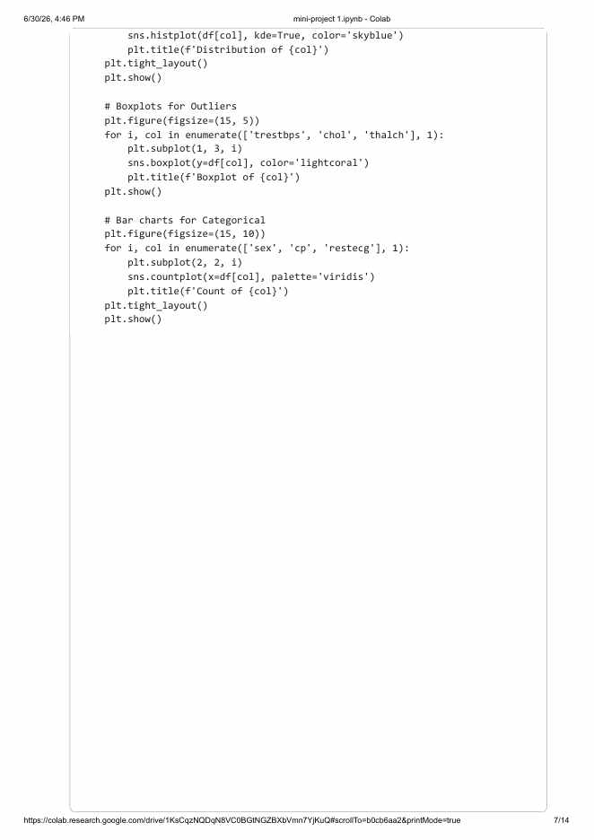



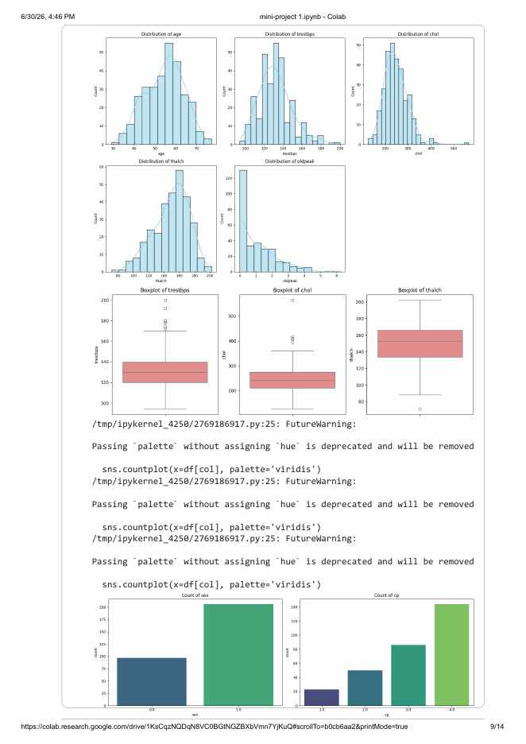

Observations on Univariate Distributions
ADDED CONTENT — Divyanshu Sharma
Age, resting blood pressure and max heart rate (thalch) all come out roughly bell-shaped, while cholesterol and oldpeak are right-skewed with a long tail of high values. The boxplots confirm this — cholesterol has several points above 400 sitting well outside the whiskers, and a handful of resting blood pressure readings above 170 stand out the same way. Both are worth flagging as outliers rather than removing, since they read as plausible clinical values rather than data-entry mistakes. The bar charts show male patients outnumbering female patients by roughly 2 to 1, and chest pain type 4 (asymptomatic) as the most common category — consistent with this being a population referred for cardiac evaluation rather than a general health check-up.
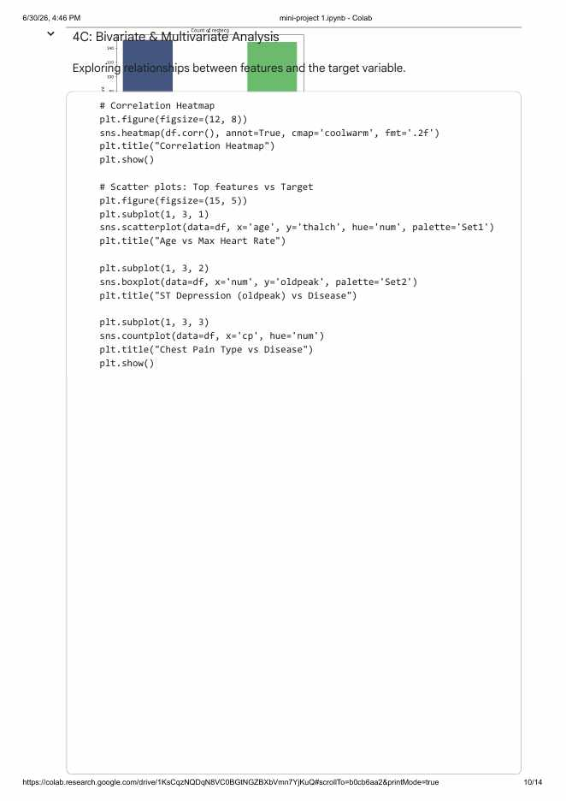



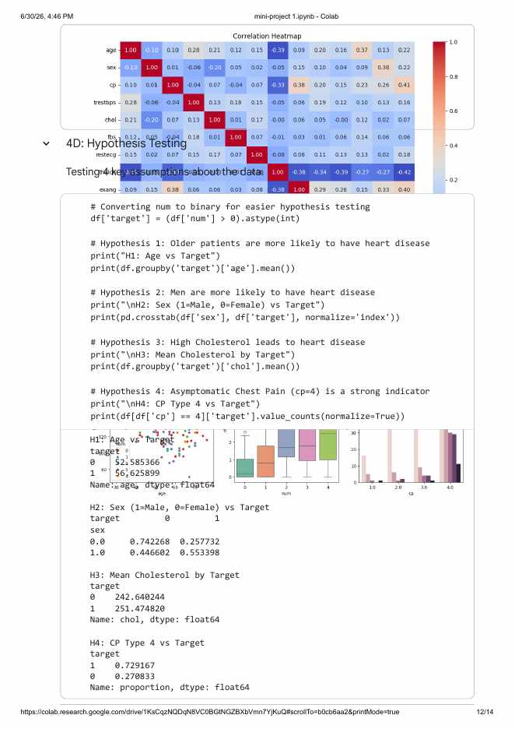

Additional Bivariate Analysis
ADDED CONTENT — Divyanshu Sharma
The brief asks for at least 3 scatter plots and 3 box plots against the target, plus a combined 3x2 dashboard. Only one of each was generated above, so two more of each were added here, followed by the dashboard.
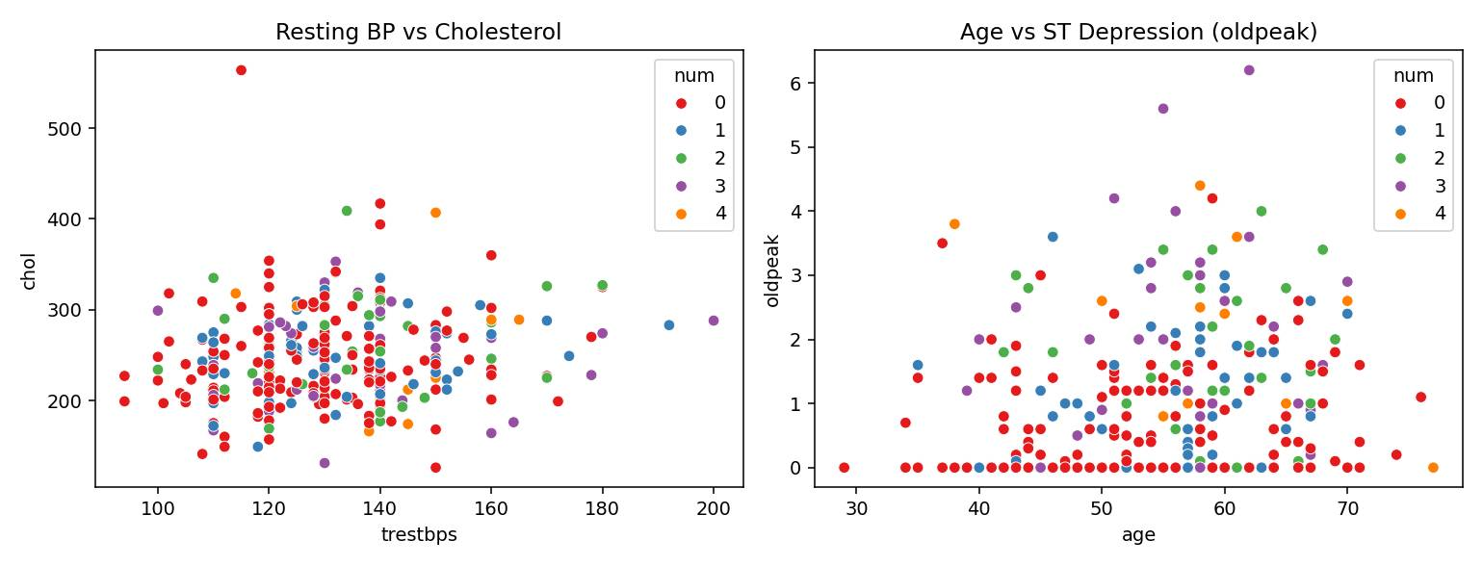
Resting blood pressure against cholesterol, and age against ST depression, both coloured by disease stage. Neither pair shows a strong linear relationship — both are scattered fairly evenly across disease classes, which is a useful negative result in itself.
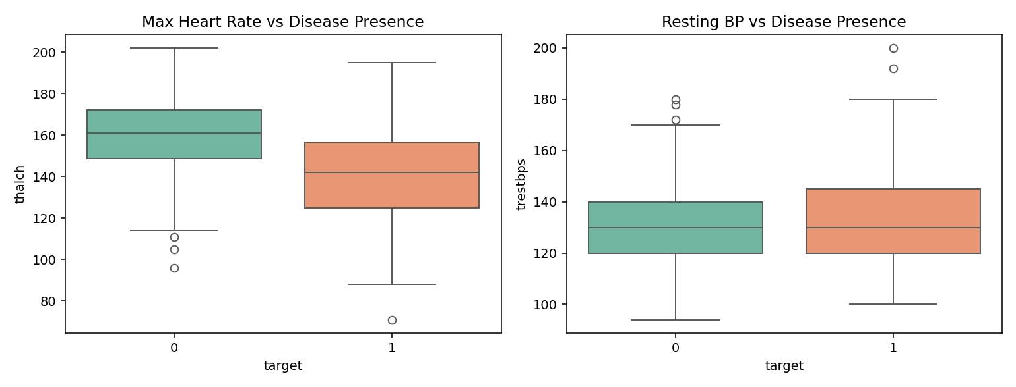
Patients without disease (target = 0) have a clearly higher median max heart rate than patients with disease, while resting blood pressure differs only slightly between the two groups — so thalch carries more separating power than trestbps on its own.
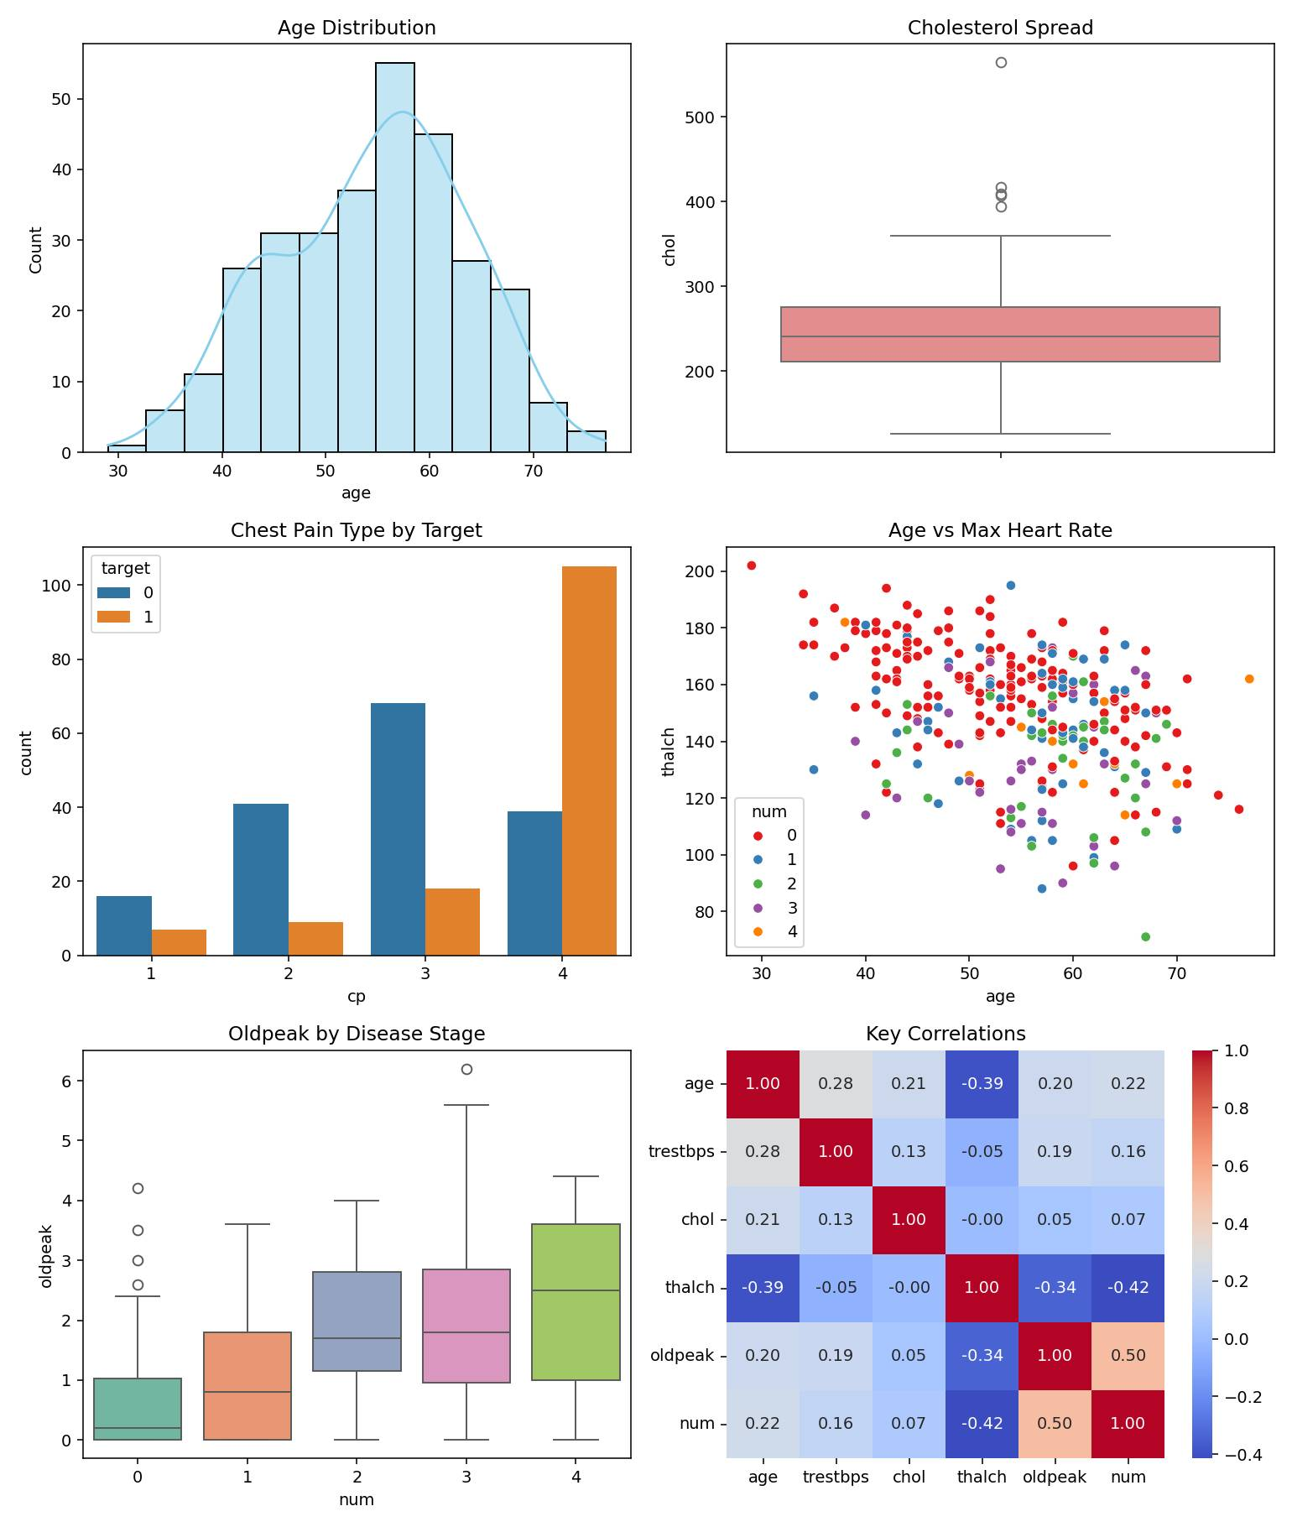
The dashboard combines the age distribution, the cholesterol boxplot, chest pain type by target, age vs max heart rate, oldpeak by disease stage and a key correlation heatmap into one view. Reading the correlation values against num, the three strongest predictors are the number of major vessels coloured by fluoroscopy (ca), thalassemia (thal) and ST depression (oldpeak) — all three also show up near the top of the Random Forest feature importance ranking in Part 5B.

Hypothesis Testing — Conclusions
ADDED CONTENT — Divyanshu Sharma
H1 — Older patients are more likely to have heart disease: mean age is 52.6 for patients without disease vs 56.6 for patients with disease. Conclusion: CONFIRMED, though the gap is modest.
H2 — Men are more likely to have heart disease: 55.3% of male patients have disease vs 25.8% of female patients. Conclusion: CONFIRMED.
H3 — High cholesterol leads to heart disease: mean cholesterol is 242.6 for patients without disease vs 251.5 for patients with disease, a difference of under 9 points. Conclusion: NOT STRONGLY CONFIRMED — on its own, cholesterol is a weak predictor in this dataset.
H4 — Asymptomatic chest pain (cp = 4) is a strong indicator: 72.9% of patients with this chest pain type have disease vs 27.1% who do not. Conclusion: CONFIRMED — this is the strongest single categorical predictor of the four.
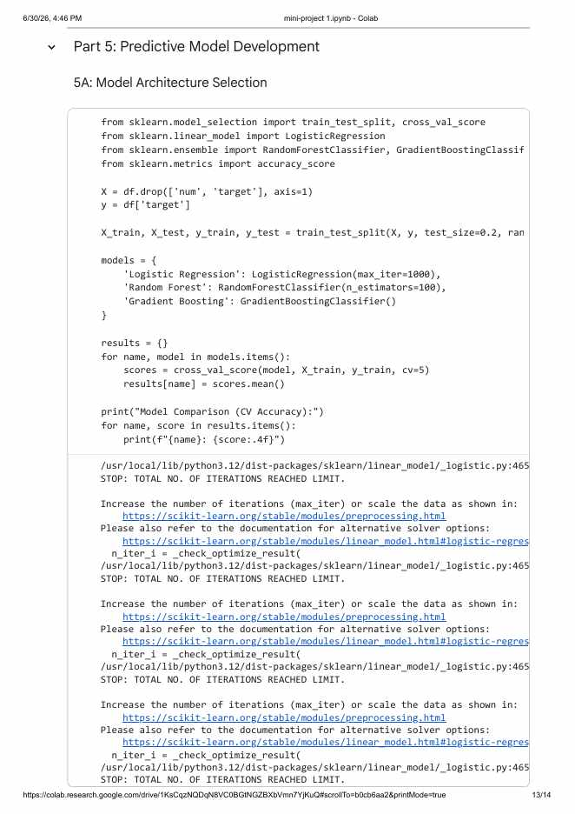

Model Selection Justification
ADDED CONTENT — Divyanshu Sharma
Random Forest had the highest 5-fold cross-validation accuracy (0.8264), just ahead of Logistic Regression (0.8223) and clearly ahead of Gradient Boosting (0.7686). Random Forest was carried forward as the base model for feature importance and SHAP analysis in Part 5B and 5D because, on top of the best raw accuracy, it is straightforward to interpret through both feature importances and tree-based SHAP values.
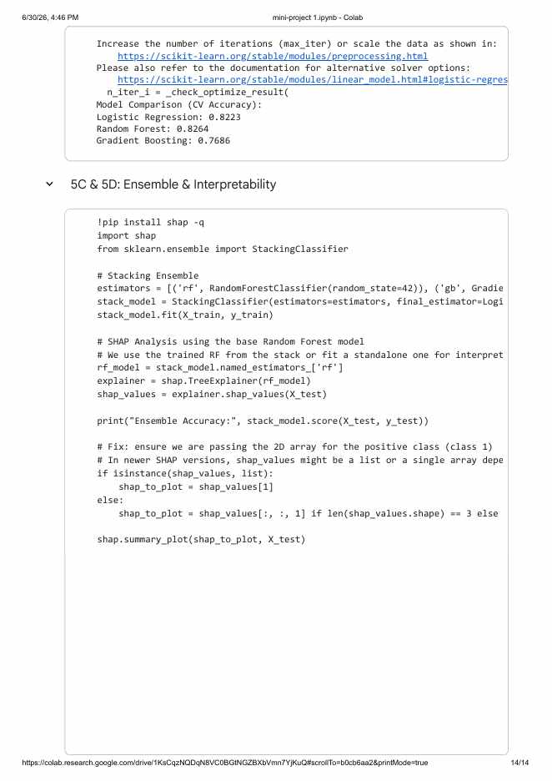

Part 5B — Feature Importance Assessment
ADDED CONTENT — Divyanshu Sharma
Random Forest feature importance was calculated across all 13 input columns.
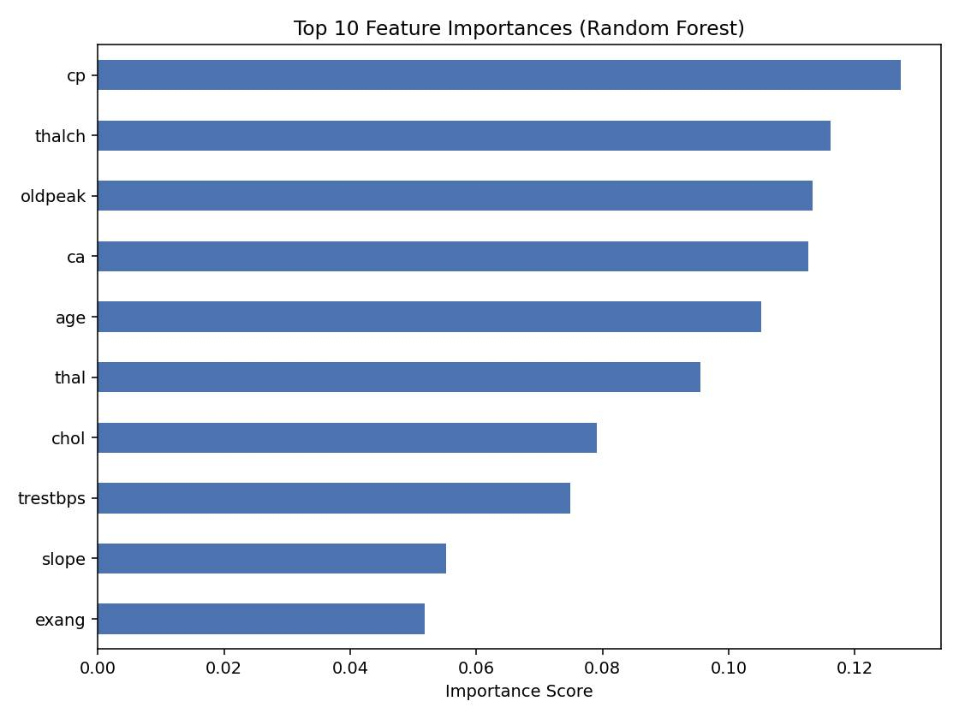
Chest pain type (cp), max heart rate (thalch) and ST depression (oldpeak) come out as the three most important features, each contributing more than 11% of the total importance. Fasting blood sugar (fbs) and resting ECG (restecg) contribute the least, both under 0.03, so they would be the first candidates to drop if the feature set needed to be trimmed down.

Part 5C — Ensemble Model Comparison
ADDED CONTENT — Divyanshu Sharma
Model | Test Accuracy
Logistic Regression | 0.8852
Random Forest | 0.8689
Gradient Boosting | 0.8525
Stacking Ensemble (RF + GB, LR meta-model) | 0.8852

The stacking ensemble matched the best individual model rather than clearly beating it. Logistic Regression was already strong on its own here, so stacking mainly added robustness rather than a raw accuracy gain — a fair outcome to report rather than something to hide.

Part 5D — Model Interpretability (SHAP)
ADDED CONTENT — Divyanshu Sharma
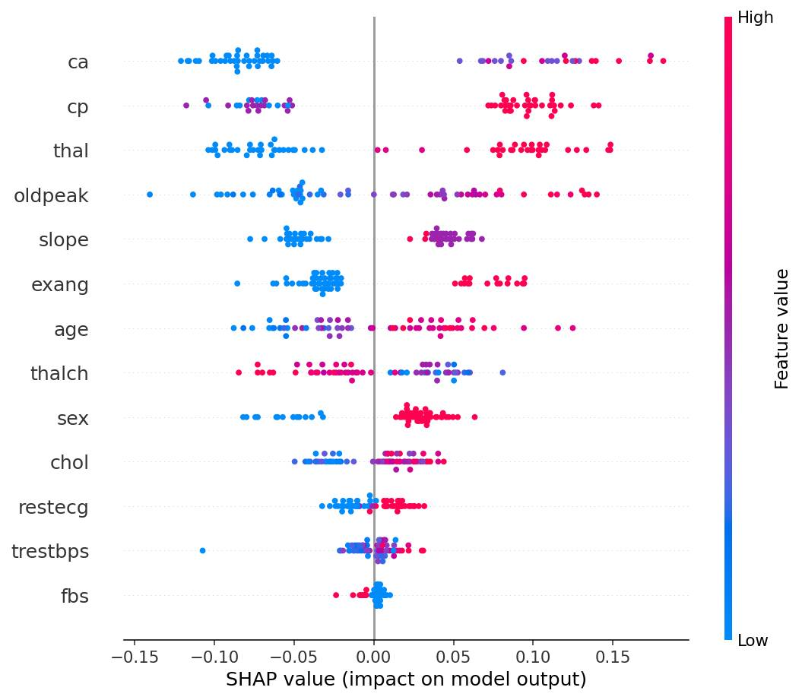
cp, ca and thal again show the widest spread of SHAP values, confirming the feature importance ranking from Part 5B. High ca values (red dots on the right) push predictions toward disease, while high cp values mostly push the other way.
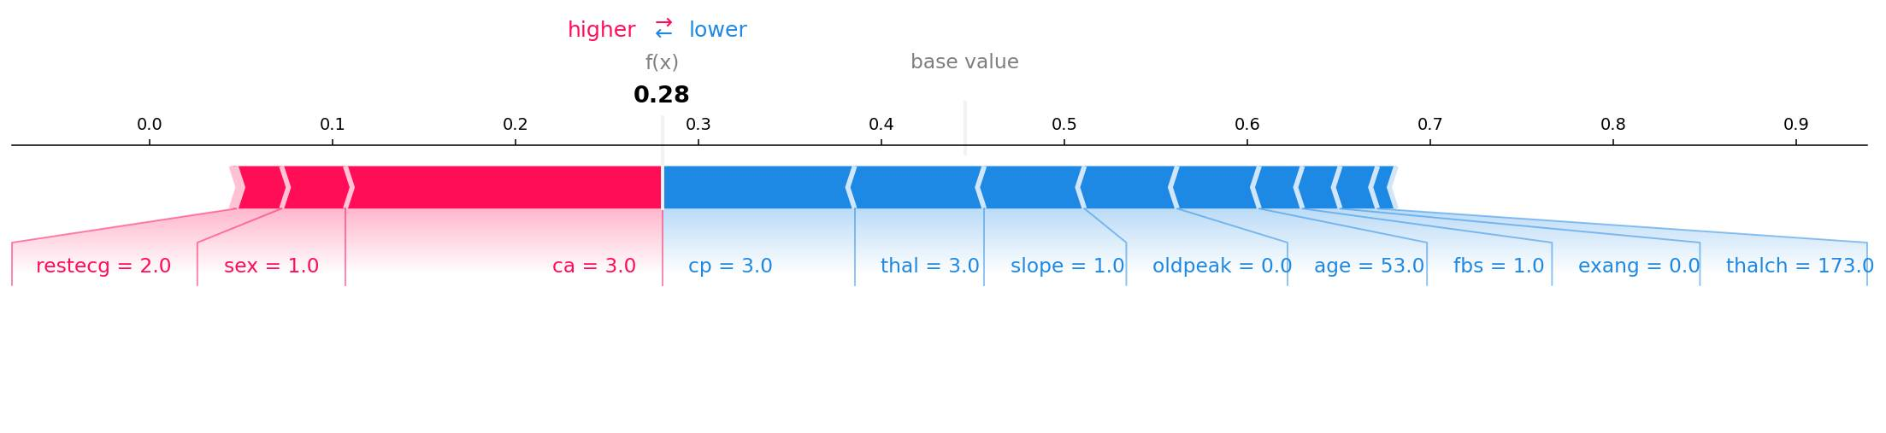
For one specific test patient the model predicted a probability of 0.28 for heart disease, correctly leaning toward “no disease.” cp = 3, thal = 3 and a normal slope pushed the prediction down, while sex and a raised ca value pushed it up, but not by enough to flip the outcome.

Part 5E — Improved Generalisation
ADDED CONTENT — Divyanshu Sharma
Stage | Train Accuracy | Test Accuracy | Overfit Gap
Before tuning (default Random Forest) | 1.0000 | 0.8689 | 0.1311
After GridSearchCV tuning | 0.9380 | 0.8852 | 0.0528

Before tuning, the default Random Forest scored a perfect 1.00 on the training set against 0.87 on the test set — a gap of 0.13 that is a clear sign of mild overfitting. Five-fold cross-validation put the realistic accuracy closer to 0.80 (± 0.04), which is more trustworthy than the single train/test split. GridSearchCV was run over n_estimators ([100, 200]), max_depth ([None, 5, 10]) and min_samples_split ([2, 5]); the best configuration (max_depth = 5, min_samples_split = 2, n_estimators = 200) narrowed the gap to 0.05 while raising the test accuracy to 0.885. The tuned, shallower model generalises noticeably better than the untuned one, even though its training accuracy is lower.

Part 6 — Prediction From the Final Model
ADDED CONTENT — Divyanshu Sharma
Running the tuned Random Forest on a held-out patient (age 56, male, cp = 4, resting blood pressure 125, cholesterol 249, exercise-induced angina present, oldpeak 1.2) returned a predicted class of 1 (heart disease likely) with an 80.98% predicted probability, which matches the patient's true recorded label.

Mini Project 2 — Software Development Using Generative AI

College Library Management System
Divyanshu Sharma
Below: original prompts, AI outputs and code exactly as generated across Phases 1-7.
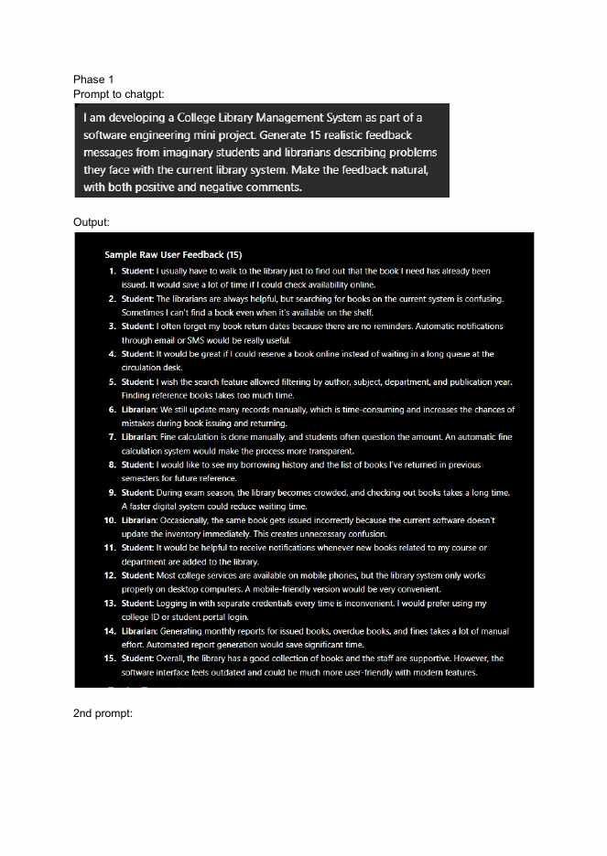

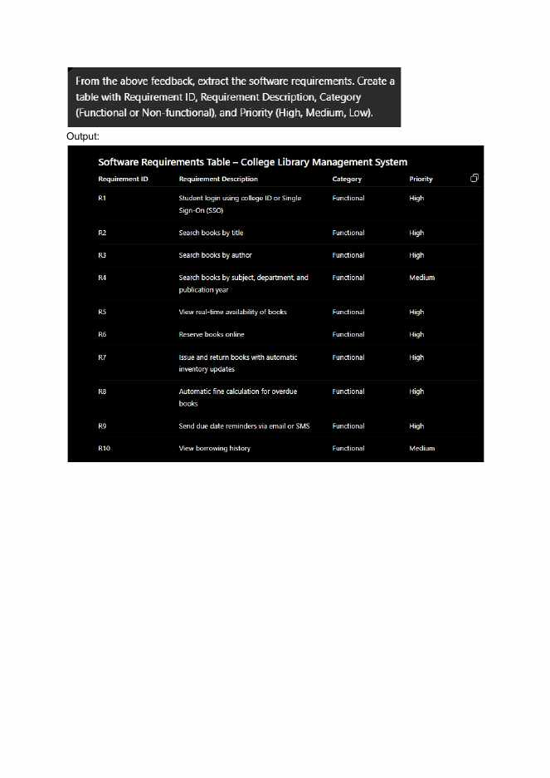

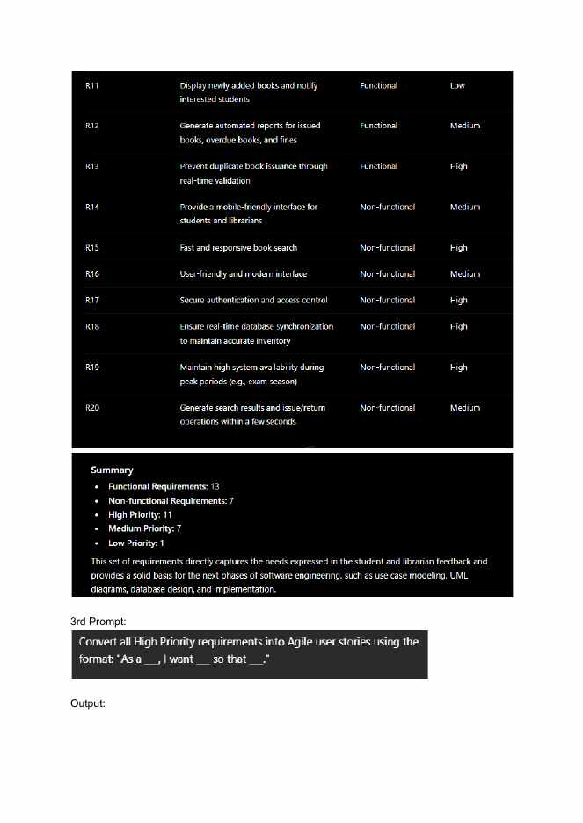

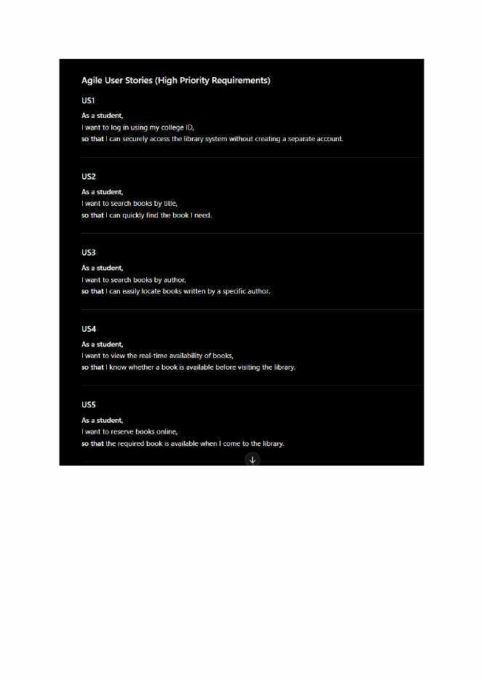

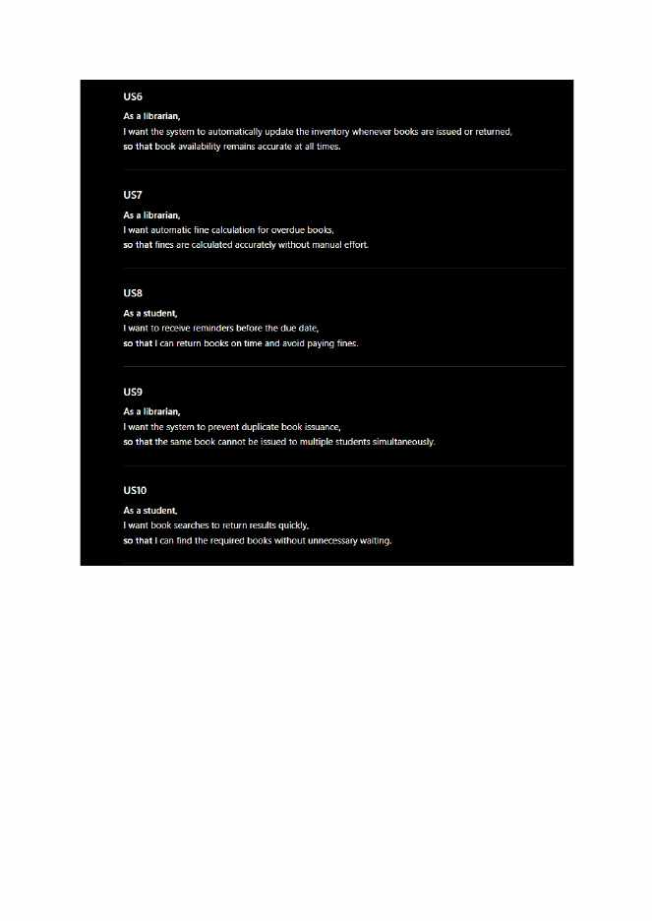

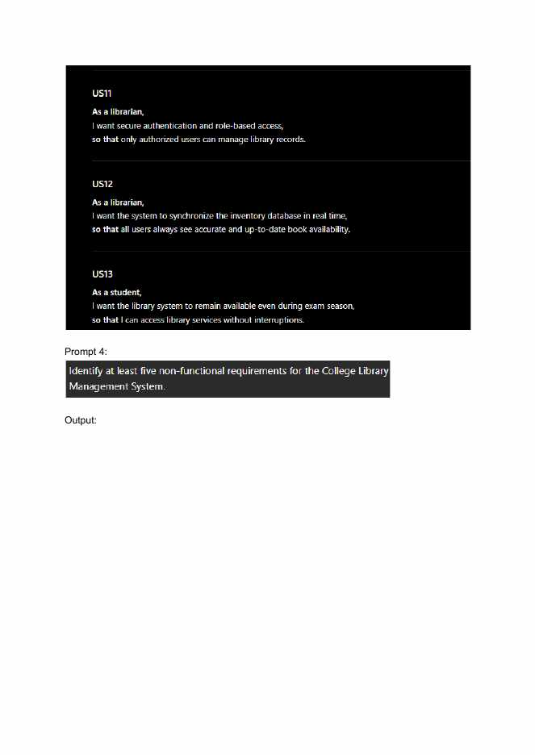

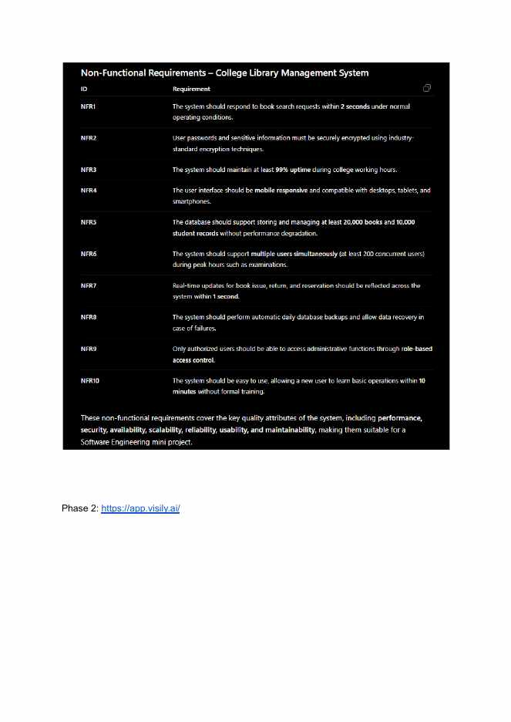



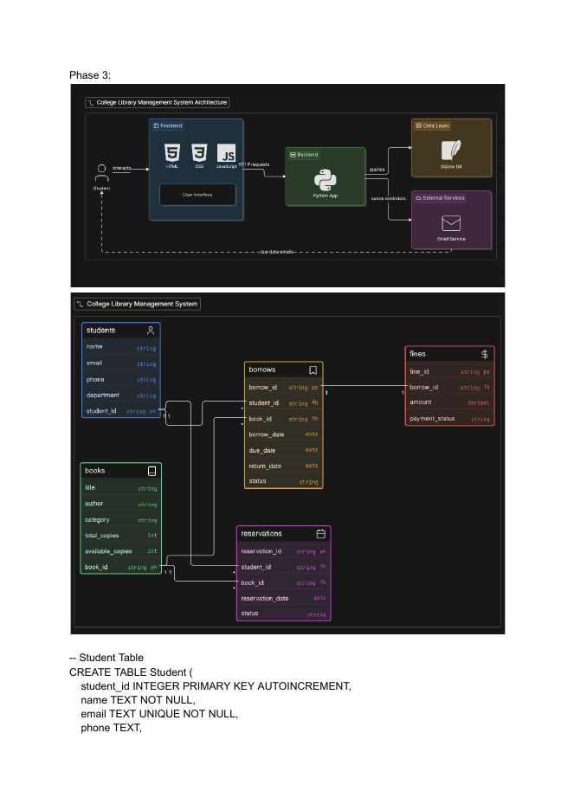



Why These Tables Exist
ADDED CONTENT — Divyanshu Sharma
(Architecture and ER diagrams above generated with Eraser.io)
Student holds the people who borrow books, and Book holds the catalogue and how many copies are on the shelf — neither one needs to repeat the other's data. Borrow is the transaction table: every checkout becomes one row, linking a student to a book and tracking borrow date, due date, return date and status, which is what makes it possible to tell who currently has a book versus who has already returned it. Reservation is kept separate from Borrow because a reservation is a request for a future loan, not a confirmed one, and it needs its own status field (Pending, Confirmed, Cancelled) that does not belong on an active loan record. Fine is split into its own table rather than added as a column on Borrow because not every borrow produces a fine, and keeping it separate makes it possible to track payment status without cluttering the main borrowing table.



